Monroe Boat Club Sailing Fleet
2024 MIDWEEK SERIES

SAILING INSTRUCTIONS

1. RULES
The races will be governed by the rules as defined in the 2021-2024 Racing Rules of Sailing (RRS), and PHRF-LE Class Rules. Each yacht must conform to the USCG requirements for their vessel and monitor VHF Ch 16/71 while racing.

2. NOTICES TO COMPETITORS
Notices to competitors will be posted on the official notice board located in the Recreation Room of MBC, and the waterside windows of the club.

3. CHANGES TO SAILING INSTRUCTIONS
Any change to the sailing instructions will be posted on the official notice board not later than one hour before the affected race.

4. SIGNALS MADE ASHORE
Signals made ashore will be displayed from the flagpole located near the waterside of MBC. When flag AP is displayed ashore, “1 minute” is replaced with “not less than 60 minutes” in the race signal AP.

5. SCHEDULE OF RACES
Open registration and competitors’ meeting will be held at MBC on Tuesday, May 14th from 6-7 pm.
The scheduled time of the warning signal will be at 6:55 pm for each race.

SCHEDULE:
REGISTRATION: Tuesday, May 14th, 6-7 pm and ONLINE at noticeofrace.net
RACING: Tuesday evenings, May 21rd through August 27th (no race July 2nd)

SPRING SERIES: May 21, 28, June 4, 11, 18, 25, July 9 (no race July 2nd)
SUMMER SERIES: July 16, 23, 30, Aug. 6, 13, 20, 27
RUM SERIES: Sept 3, 10, 17

THERE WILL BE NO MAKEUP RACES SCHEDULED IF A RACE IS CANCELLED FOR ANY REASON

6. CLASS FLAGS AND ORDER OF STARTS
Classes will start in the following order: One PHRF start followed by one JAM start
Approximate Starting Times: 6:55 pm Warning Signal (PHRF)

PHRF Class Pink Start 7:00 pm
JAM Class Gray Start 7:05 pm

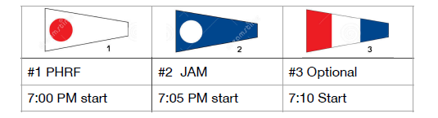
On-water postponement: Code Flag "AP" and two sound signals. The Warning Signal will be made one minute after lowering the "AP" flag.
7. RACING AREA
The racing area will be in western Lake Erie from the MBC/NCYC North mark in La Plaisance Bay, using the MBC/NCYC Racing Marks. (See “Exhibit A”)

8. MARKS
All marks will be orange can buoys, identified with “NCYC Racing Mark.”

9. COURSES
The courses may be triangular or windward-leeward. The race committee signal boat will display the selected
course, designated by a black number on a white background indicating marks to round and rounding order no later than the warning signal.

Course # | Class | Rounding Marks  - (direction) | Nautical Miles
1 | PHRF | Start-W-E-Finish (port) | 6.8
 | JAM | Start-W-C-Finish (port) | 4.8
2 | PHRF | Start-W-S-Finish (port) | 6.8
 | JAM | Start-W-C-Finish (port) | 4.8
3 | PHRF | Start-S-W-Finish (stbd) | 6.8
 | JAM | Start-C-W-Finish (stbd) | 4.8
4 | PHRF | Start-S-E-Finish (port) | 6.8
 | JAM | Start-C-E-Finish (port) | 4.8
5 | PHRF | Start-E-W-Finish (stbd) | 6.8
 | JAM | Start-E-C-Finish (stbd) | 4.8
6 | PHRF | Start-E-S-Finish (stbd) | 6.8
 | JAM | Start-E-C-Finish (stbd) | 4.8
7 | ALL | Start-W-C-Finish (port) | 4.8
8 | ALL | Start-C-W-Finish (stbd) | 4.8
9 | ALL | Start-E-C-Finish (stbd) | 4.8
10 | ALL | Start-C-E-Finish (port) | 4.8
11 | ALL | Start-W-Finish (port) | 4.0
12 | PHRF | Start-W-N-W=Finish (port) | 8.0
 | JAM | Start-W-Finish (port) | 4.0
13 | ALL | Start-S-Finish (port) | 5.6
14 | PHRF | Start-S-N-C-Finish (port) | 8.4
 | JAM | Start-S-Finish (port) | 5.6
15 | ALL | Start-E-Finish (port) | 4.0
16 | PHRF | Start-E-N-E-Finish (port) | 8.0
 | JAM | Start-E-Finish (port) | 4.0

10. THE START
Races will be started in accordance with RRS 26 with the warning signal given 5 minutes before the starting signal.
The starting line will be between an orange flag on the R/C boat and the North mark. Boats whose warning signal has not been made shall avoid the starting area.

11. INDIVIDUAL RECALLS
The R/C boat will fly the “X” flag and signal in accordance with Rule 29.1, and MAY attempt to notify individual yacht(s) by hail. However, failure of a yacht to hear her recall shall not relieve her of her obligation to start correctly. There will be no general recalls.

12. THE FINISH
The finish line will be between an orange flag on the R/C boat and the North mark unless shortened or abandoned (See RRS 32).

13. TIME LIMIT
The time limit for each race will be 2 hours for the first boat to finish in each division. Boats finishing more than 90 minutes after the first boat that sails the course and finishes will be scored DNF. This changes RRS 35.

14. PROTESTS AND REQUESTS FOR REDRESS
Protest flags must be flown. Hearing Request Forms ( formerly ”Protest Forms” ) are available on the official notice board. Hearing Requests shall be delivered to the MBC Sail Fleet Board folder within 1.0 hour after the race committee/finish boat docks.

The yacht requesting a hearing must notify the R/C boat at the finish line of her intent to protest and the sail number of the protested yacht. Hearings will be held as soon as possible after racing in the Commodore’s Room at the clubhouse. All interested parties must be present.

A boat that has taken a penalty under RRS 31.2 or 44.1 shall notify the Race Committee after it has finished the race.

15. SCORING
- The Low Point System of Appendix A of the RRS will apply. Results for a series will be calculated on the best five (5) scores in each series; this changes RRS Appendix A-2. The overall championship will be decided based on the best ten (10) scores in both series. No makeup races will be scheduled if a race is cancelled for any reason; this changes RRS Appendix A-2.

- For a boat to be scored, it must be properly registered prior to the start of that boat's first race. Proper registration includes receipt of the following by the Racing Chairman or Sail Fleet Captain; completed registration form, payment for registration, current proof of insurance, and current PHRF or GLMHA certificate.

- All competing MBC members are required to perform Race Committee duty once during the season. RC duty is scored as 1st place in Class and Division Overall. As a canceled or abandoned race is not scored, the scheduled Race Committee will not be awarded any points. Should additional Race Committee duties be warranted, those occurrences will be counted as a race sailed, and scored as1.5th place in Class and 1.5th place OA.

16. SAFETY
- Each competitor is responsible for the personal safety of him/herself, his/her crew and yacht. It shall be the sole and inescapable responsibility of the skipper and crew of the yacht to decide whether or not to start, continue, or finish a race.
- By participating in this event each competitor agrees and acknowledges that sailing is a potentially dangerous activity with inherent risks. These risks include strong winds and rough seas, sudden changes in weather, failure of equipment, boat handling errors, poor seamanship by other boats, loss of balance on an unstable platform and fatigue resulting in increased risk of injury. Inherent in the sport of sailing is the risk of permanent, catastrophic injury or death by drowning, trauma, hypothermia or other causes.

- All yachts shall follow the U.S. Coast Guard requirements for carrying lights at night.
- Each boat MUST monitor VHF Channel 16/71 during each race.
- Retirement: A yacht that retires shall notify the Race Committee, verbally or using VHF channel 71, before leaving the racing area. If that is not possible, the yacht shall notify MBC as soon as possible. The club monitors VHF channel 16. Club telephone: (734) 243-8935.

17. RADIO COMMUNICATION
A boat shall neither make radio transmissions while racing nor receive radio communications not available to all boats. This restriction also applies to mobile (cell) telephones except to call the club at (734) 243-8935.

18. TROPHIES AND PRIZES
Award flags will be awarded to the top three finishers of each class at the Annual Banquet. Exceptions: only one flag per season is awarded in a class with only one boat. Overall Trophies will be awarded to the top three finishers in each class (PHRF/JAM).

Exhibit “A”

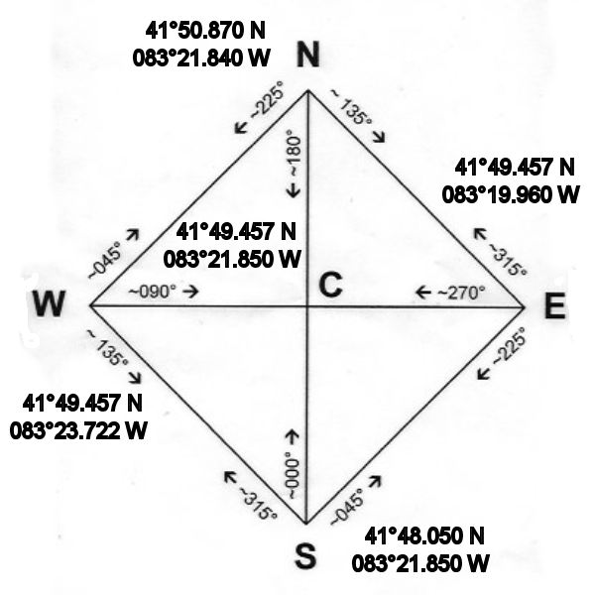

Buoy coordinates are approximate and the buoys are subject to movement by storms. If a mark is missing, the competitors will use these coordinates to make a navigational rounding.

